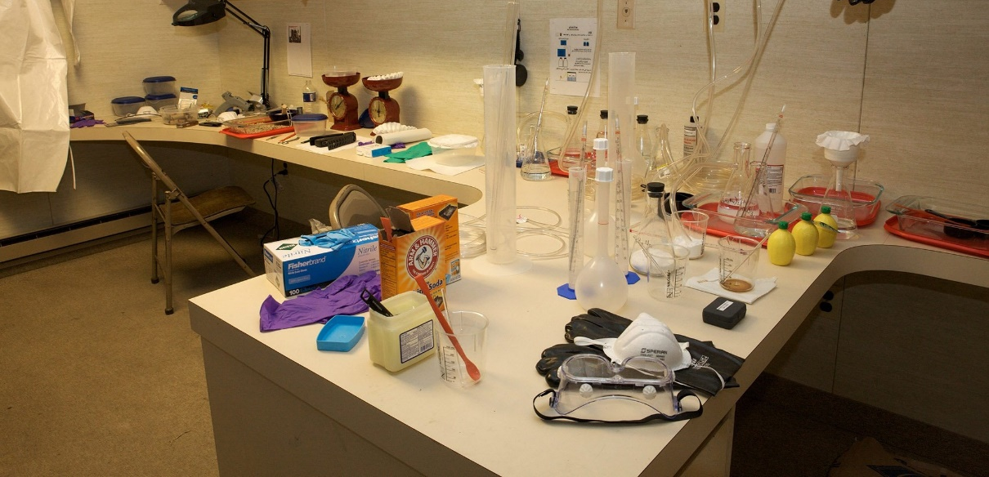

Emergency Response to Domestic Biological Incidents (PER-220)
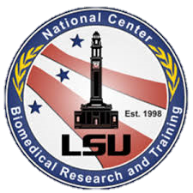Date:
August 30-31, 2017
8:00 am – 5:00 pm
Location:
Davis Hospital and Medical Center
1600 W. Antelope Dr.
Layton, UT 84041
Registration:

Utrain 1071342

Contact:
Art Deyo
Deputy State Fire Marshal
adeyo@utah.gov
(801) 618-9277

Description
This course is designed to help participants safely and effectively respond to a biological incident by using an integrated approach. The course provides detailed information about various biological agents and possible methods of dissemination whether naturally occurring or intentional. Participants will identify appropriate assessment and response actions and will review personal protection, containment measures, and tools that may be accessed during a biological incident.

Target Audience

- Administrators
- Directors
- Mid-level Supervisors
- Special Operations Teams
- Emergency Responders
- Physicians
- Nurses
- Veterinarians

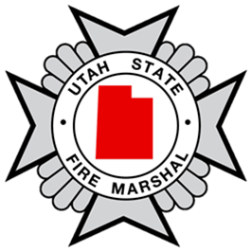
Course Length
16 hours (1.6 hours CEU)

