
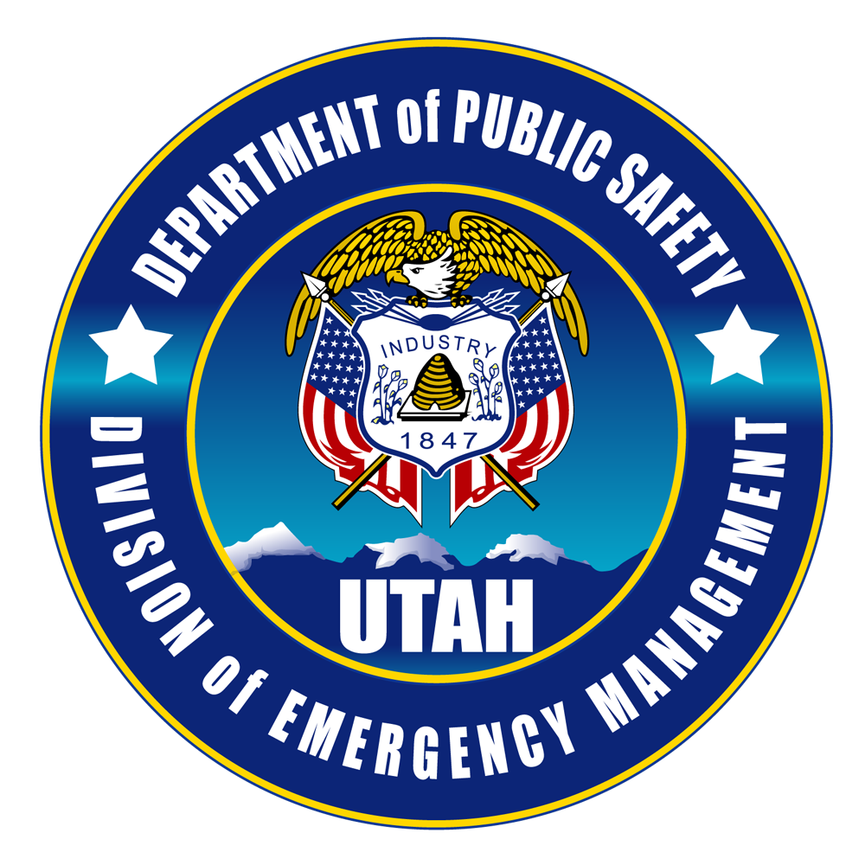
The Federal Emergency Management Agency (FEMA) Region VIII
FEMA’s Emergency Management Institute (EMI)
and the
Utah Dept. of Public Safety-Division of Emergency Management

invite you to attend
L0552, Continuity of Operations (COOP)
for Tribal Governments course
September 12-13, 2017
Cedar City, Utah

Course Purpose: To give Tribal governments a foundation for ensuring operation of essential government functions during emergency events.
This 2-day course provides tribal representatives with an understanding of how to develop and implement a Continuity of Operations program to ensure continuity of community essential functions across a wide range of emergencies and events. Topics include legal basis for continuity, continuity planning, determining essential functions, vital records management, and pan flu implications for continuity operations.
Specific topics include:
- Continuity planning principles
- Conducting a risk assessment
- Identifying Essential Functions for your tribal government
- Supporting activities and capabilities for a sound COOP program
- Developing a continuity plan and plan activation
Intended Audience: tribal leaders, tribal emergency managers, tribal community response personnel, emergency support functions, program directors including education, health, natural resources, transportation, public works, facilities management, security, environmental programs, human resources, managers for any tribal enterprises.

All travel expenses are the responsibility of the student’s organization
For Utah Tribes only – if you need assistance with lodging cost please contact Anna Boynton.
NOTICE: You will be required to enter a FEMA Student Identification Number (SID) on your application. PRIOR TO THE CLASS, please obtain an SID by going to https://cdp.dhs.gov/femasid/ and PLEASE BE SURE TO BRING YOUR FEMA SID NUMBER WITH YOU TO THE CLASS!

To register, please go to U-TRAIN at: www.utah.train.org. If you don’t have an account please open one. “How to Create a U-TRAIN Account” at the top of the Training page at: http://dem.utah.gov/training-and-exercise/training/ and follow the instructions. Course #1067235 If you need additional help in registering please contact Ted Woolley at 801-556-3166.
Classroom space is limited to 30 participants

For questions about the course, please contact Anna Boynton at 801-718-5306 or aboynton@utah.gov.

